Project Structure:
Lexer/Tokenizer (Lexical Analysis)
The tokenizer reads a string of text into a list of tokens. This step is not necessary, and can be merged into the parsing stage, but it improves code organization by incorporating it. The tokenizer usually uses linear algorithms in order to build the resulting list.

void foo() { println(“Hello World”) }
becomes a list of tokens, split like this:

void foo() { println(“Hello World”, 14.0f32) }

The lexing stage is also responsible for discarding comments and whitespace
Parser (Syntax Analysis)
The parser takes a list of tokens and generates an abstract syntax tree. Because it is responsible for generating a tree structure, it will use recursive algorithms to do like such. Each branch in the AST has a node at the very top. The parser works by having a bunch of procedures that can increase the current read index, and then return a node.

For example, a procedure for generating multiplication nodes will work like such.
- Detect a number or an expression node
- Increment the read index
- Detect a multiplication symbol (*)
- Increment the read index
- Detect another number, or another expression node
- Increment the read index
- Create a multiplication node, with the two operands as its children.

When that procedure finishes, it will escape to the outer procedure that activated it. Whatever procedure called readMultiplicationNode() will now have access to the multiplication node, and can use it as one of its children. For example, a plus node generation procedure.

AST
The abstract syntax tree is a representation of the program syntax in a form that can be read using recursive algorithms.

It looks something like this:
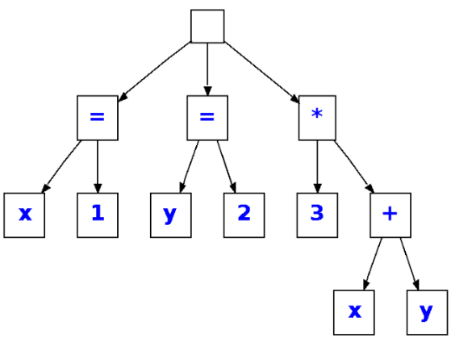
This AST represents an algorithm that assigns x to 1, y to 2, and then takes the result of 3*(x+y)
Semantic Analysis
This stage will recursively look through the parser’s generated AST, making sure each type is valid, and that the code makes sense. For example, for a statement like this :
i32 example = Foo.bar(14)
The semantic analyzer will ensure that the Foo structure has a function called bar that returns an i32. Otherwise, it will error. Some of the cached information, such as function déclarations, may be passed over to the IR generation step just to avoid repeated operations.
Intermediate Code Generation
This stage takes the AST and converts it into an intermediate format that more closely resembles how the source code will be structured.
assign x = 1
assign y = 2
temp1 = x + y * temp1
temp2 = 3 * temp1
Code Optimization
This stage will just simplify the IR code. It goes through various processes to achieve this. Looking at the previous example, first it will replace all instances of ‘x’ with 1, and all instances of y with ‘2’, since x & y are just constant numbers. Then, it will evaluate the expression on the right of temp1, since 1+2 can just be simplified to 3. Since temp1 also is just a constant number 3 now, we can simplify further and realize temp2 just equals 9. There’s a number of code optimizations that can be performed by the compiler, I don’t know how many of them I’ll implement myself though.

Code Generation
This final stage takes the IR and converts it into bytecode. For the following (unsimplified) IR, this is how it would be done.

assign x = 1
assign y = 2
temp1 = x + y
temp2 = 3 * temp1

Looking at the first statement, we are just assigning a variable to 1. This means we can just push the integer 1 to the top of the stack. We repeat that again but with the number 2. We make sure the code generator is keeping track of where the values are stored relative to the stack frame. For x, it would be located at offset 0 since it’s the first value. For y, it would be at offset 4, since our variable x is already taking up byte 0, 1, 2, and 3.

Now, we want to load our two variables to some register. The virtual machine can’t perform math or logic operations directly to data held on the stack, so it must first copy the data onto the virtual registers. Registers are just very small pieces of memory storage that is held very close to the CPU (or virtual CPU in our context). So we will use the load instruction to load our variable x at offset 0, and our variable y at offset 4. Then we use the add operation to add the two registers together. All in all, it works out to looking something like this:

// we are adding two constant 32-bit integers to the stack
// the integers are 1 and 2
pushconst32 1
pushconst32 2

// Now we are loading them onto the registers and adding them
loadlocal32 0 onto register1
loadlocal32 4 onto register2
add register2 to register1
push32 register1
// And finally pushing them back onto the stack

loadconst32 3 onto register1
loadlocal32 8 onto register2
multiply register2 to register1
push32 register1

This isn’t the most optimized bytecode, as we unnecessarily push a number to the stack and then immediately put it on the register again, but it works for now.

Virtual Runtime
Now this is the stage that is more specific to what I am doing, as I am developing a custom bytecode. The native machine doesn’t know how to interpret my bytecode, it’s practically a foreign language, so I have to give it a translator, a piece of software called a virtual machine. It reads my bytecode and tries to make sense of it. It will contain a set of virtual registers, a virtual stack, and some modular components for modifying how certain behaviours work like memory management. Also, it will be responsible for making sure every call made to external libraries is properly handled. That means that every time the print line function is called, that message will be sent over to whatever piece of code handles the terminal output.

